NEW ERA DISTRICT 84th ANNUAL CONGRESS SESSION
President and Dean Annual Address
Friendship Baptist Church, 3530 Chelsea Drive
Kansas City, MO. 64128
Rev. James A. Terrance, Jr. - Pastor
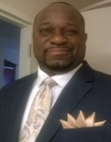
President Robert L. Smith, II – Friday night, June 5, 2026, 7:30 p.m.

My name is Robert. Smith II. I am a loving husband to Angelita M. Smith, a father of three adult children, and a grandfather of two.

I am a 1983 graduate of Lincoln Academy College Preparatory High School. I graduated from Carver Baptist Bible College with an Associate of Arts Degree in Biblical Studies. I have a Master of Science Degree in Bible and Theology from Calvary Bible College and Theological Seminary.

I serve as the Minister of Christian Education at Ebenezer M.B.C. of Jesus Christ, where Rev. Kevin McNeil is the pastor. I currently serve as the President of the New Era Missionary Baptist District Congress of Christian Education.

I have an active, faithful, and obedient relationship with Jesus Christ, a passion and genuine love for all God’s children, as well as a compassionate heart to be a witness for Jesus Christ and edify the body of Jesus Christ.
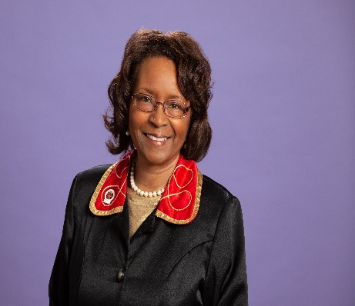
Dean Dr. Sandra L. Jones – Monday night, June 1, 2026, 7:30 p.m.

My name is Sandra L. Jones, and I am the wife of Thad W. Jones for the past 46 years and the mother of Krystle D. and Michael W. I serve and love Jesus Christ. I am committed to His Word, devoted to serving others, and intentionally sharing my faith.

I graduated from Lincoln High School in 1974 and later earned a Bachelor’s Degree in Business Administration from William Jewell College, with a minor in English Literature completed at Harlaxton College in Grantham, Lincolnshire, England. In 1999 I earned my Master of Arts in Human Resource Management from Webster University. I earned my Master of Divinity in 2009 and Doctor of Ministry in Christian Education in 2015 from Western Baptist Bible College.

I serve in multiple ministries within the New Era District Association, including the WMU and the District Choir. I teach at Western Baptist Bible College and serve as Dean of Academics. I am a servant leader with Bible Study Fellowship (BSF) at Abundant Life Church in Lee’s Summit. I am a certified Dean and instructor through NBCUSA, Inc.

I am a 60+-year member at Second Baptist Church in Independence, Missouri, under the leadership of Rev. Jon B. Gray where I serve as Christian Education Director, Bible Study Coordinator, Young Adult Sunday School Teacher, Director of Music & pianist.

